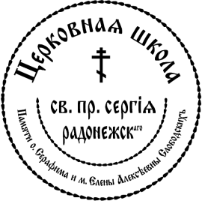

Returning
2016/2017

#1 Child’s Name DOB_________Namesday_____________

#2 Child’s Name DOB_________Namesday_____________

#3 Child’s Name DOB_________Namesday_____________

#4 Child’s Name DOB_________Namesday_____________

#5 Child’s Name DOB_________Namesday_____________

Mother Father

Name : __________________________________

Cell phone : __________________________________

Check # ___________ Cash Amount__________

Assembly Fee:
$400 for the first child
$250 for the second child
Please make check payable to: “Tolstoy Foundation, Inc.”
Memo: “Assembly Fee”

I have read the Rules of Conduct (on the back of this form) and will adhere to them.

__________
Parent’s Signatures Date

St. Sergius Learning Center•104 Lake Road, Valley Cottage, New York 10989
845-268-2037

